Maths Word Problems

- Number each problem clearly and remember to show all working. Eg.

1. 28 -
15
13
Sophie has 13 more gel pens than Yasmine.

PROBLEM
1. Yasmine has 15 gel pens. Sophie has 28 gel pens. How many more gel pens has Sophie than Yasmine?  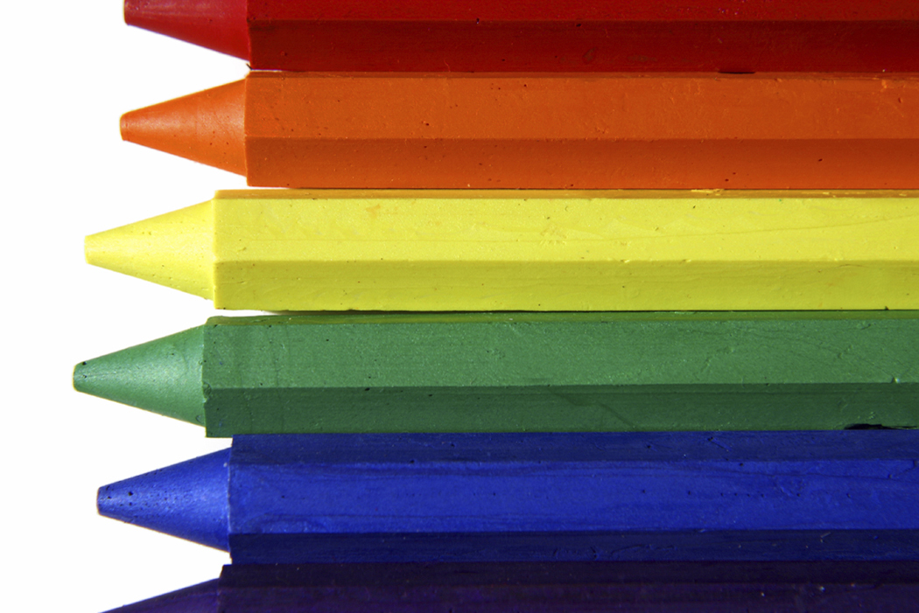 | 2. Khaled has 10 cents more than me. I have 38 cents. How much does Khaled have?   | 3. There are 18 gloves in the cloakroom. How many pairs of gloves might that be?  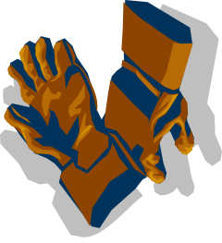
4. There are 12 biscuits in a pack. Sam ate ¼ of them. How many did he eat?  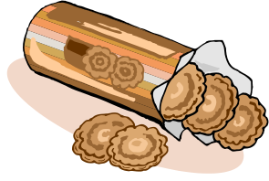 | 5. Tom’s small birthday cake is divided equally between four people. What fraction of the cake do they each get? | 6. I think of a number and add 10. The answer is 68. What is my number?  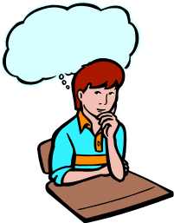
7. I take 5 from a number and get 11. What is the number?  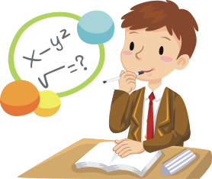 | 8. How many less than 17 is 6?  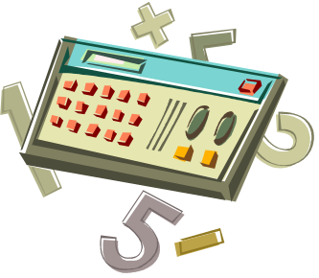 | 9. 41 children are in the hall. Another 8 children come in. How many children are now in the hall?
10. Cakes cost 50 cents. How much will it cost for 5 cakes?   | 11. Go-karts have 5 wheels. How many wheels on 7 go-karts?  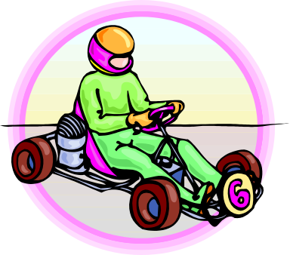 | 12. Jessica has a bag of 30 marbles. At playtime her friend Sarah takes 8 marbles out of the bag and Susie takes 12 marbles out of the bag. How many are left in the bag?  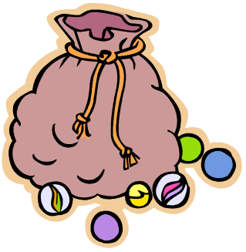
13. In a pack of stickers there are 4 plain stickers and 2 shiny stickers. I buy 3 packs of stickers. How many shiny stickers will I have? | 14. A gel pen costs 11 cents more than a pencil. A pencil costs 13 cents. How much does a gel pen cost? | 15. Fatima paid for a can of drink. It cost 70 cents. She paid exactly for the drink using 4 coins. Which coins did she use?
16. My hand is 11cm long. My Dad’s hand is 12cm longer. How long is my Dad’s hand?  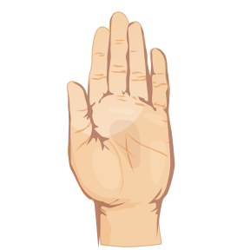 | 17. Billal walked to school. He set off at 8.15 and arrived at 8.45. How long did it take him to walk to school?   | 18. A sack of potatoes weighs 5kg. Mum buys 3 sacks of potatoes. How many Kg of potatoes does Mum buy?  
19. You have 50g of chocolate. How many 10g pieces can you make?  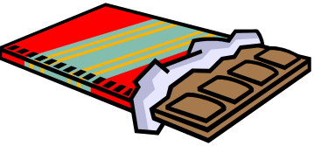 | 20. Maysam is 112cm tall. Wendy is 131cm tall. How much taller is Wendy than Maysam? | 21. Jamie counts in threes. Lee counts in twos. Will they say any of the same numbers? Which ones?
22. All the coins in my moneybox are 10 cent pieces. I want to buy a toy plane that is 68 cents. How many 10 cent pieces will I need to take out of my moneybox to pay for the plane? | 23. My shoelace is 30cm long. I accidentally snap it. The two pieces are exactly the same length. How long are the pieces of shoelace?  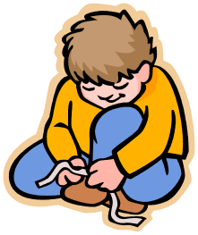 | 24. 86 children are in the hall. 50 go out to watch a video. How many are left in the hall?  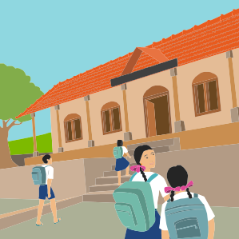
25. There are 84 seats in the theatre. 80 people come to the theatre for the show. How many seats are empty?  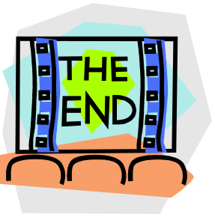 | 26. There are 32 fish in a pond. 28 fish are orange. How many are not orange?  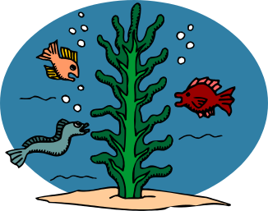 | 27. 58 mums and 21 dads are waiting outside school. How many parents are outside school altogether?  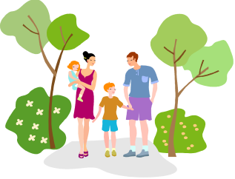
28. A remote controlled car costs $21. A robot costs $18. Gran buys me a remote controlled car and a robot. How much did she spend?  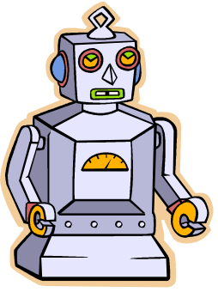 | 29. There are eleven players on a football team. How many players altogether in a football match?  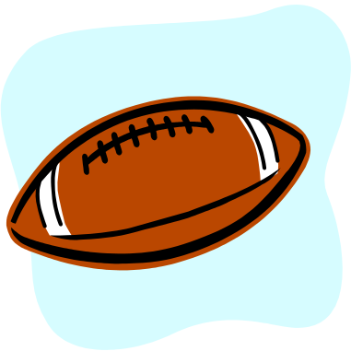 | 30. I buy a comic for 40 cents. I pay with a $1 coin. How much change will I get?  

